- (1 mark)
Which statement is true?
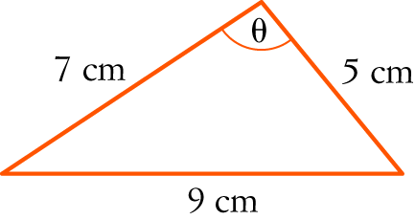
A B
C D
E

- (1 mark)
A B C D E 1

- (1 mark)
Which statement is not correct?
A
B
C
D sin (x − y) = sin (y) cos (x) − cos (y) sin (x)
E

- (1 mark)
Solve cos (2x) = −1 for 0 ≤ x ≤ 2π.
A x , B x C x = 0, π, 2π D x E x = π,

- (1 mark)
Find the amplitude and period of the following graph.
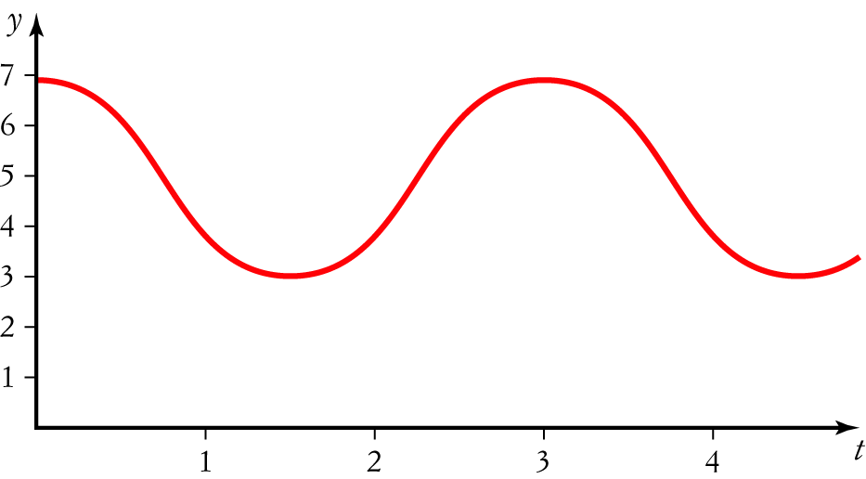
A Amplitude 4, period 4 B Amplitude 4, period 3
C Amplitude 4, period D Amplitude 2, period 3
E Amplitude 2, period
- (1 mark)
The equation of the function below is:
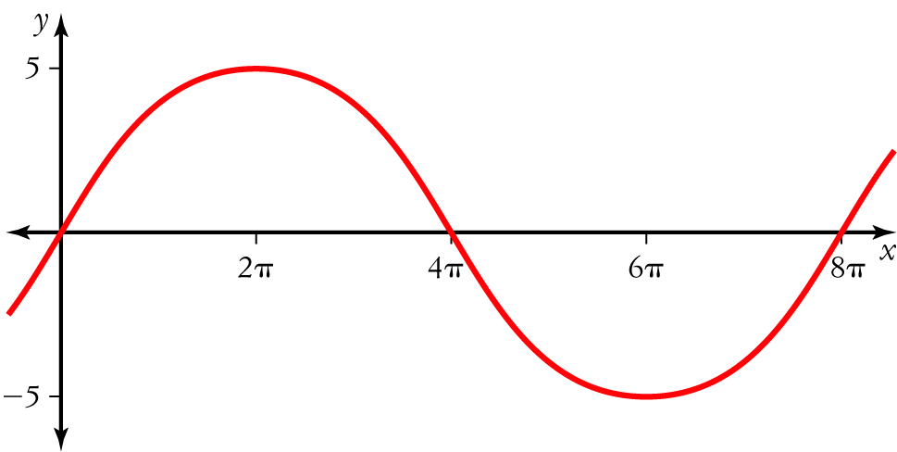
A y = 8 sin (5 x) B y = 5 sin (8 x)
C y = 5 sin D y = 5 sin
E y = 5 sin (4πx)

7. (1 mark)
Find the exact value of sin (105°).
A B
C D
E

Short and Extended Answer Questions – show working for questions worth more than 2 marks

- (2 marks)
Convert the following to radians, giving exact values.

- (2 marks)
Convert the following radians to degrees.

- (3 marks)
State which quadrant each of the following angles are in.
- −285°

- −

- (6 marks)
Evaluate x correct to one decimal place.
- 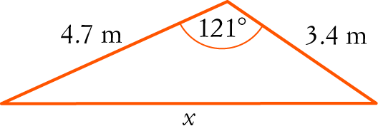

- 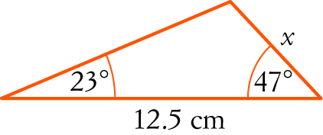

- (5 marks)
If sin (a) = and cos (b) = , find the exact value of cos (a + b)

- (2 marks)
Using your CAS calculator, graph the functions y = 2 cos (x) and y = x − 1 on the same set of axes and graphically solve 2 cos (x) = x − 1 (you do not need to draw a graph).

- (2 marks)
Expand
- tan (2a + b)

- cos (5a − 3b)

- (5 marks)
The circumference of a circle is 20 cm. Find the angle subtended at the centre if it cuts off a sector with an area of 15 cm2.

- (3 marks)
Show that cos (2x) = 1 − 2 sin2 (x)

- (6 marks)
Solve
- cos (x) = for 0 ≤ x ≤ 2π

- Solve 2 sin2 (θ) − 1 = 0 for 0° ≤ θ ≤ 360°.

- (13 marks)
The diagram below shows a regular pentagon with sides of 10 m.
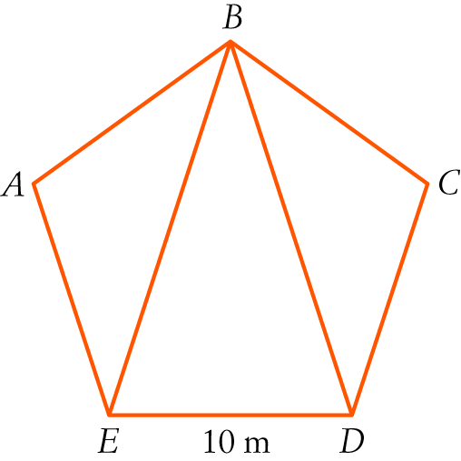

- Use the sum of angles in a triangle to find the angle sum of any pentagon. [1]

- Find the size of each angle inside a regular pentagon. [1]

- Find the length of BE in the pentagon above. [3]

- Find the area of the pentagon. [8]

More space available over page.

End of Test

